SIMATS ENGINEERING (SAVEETHA SCHOOL OF ENGINEERING)
Course Code & Title: | ECA5604 -5G/6G COMMUNICATION | Course Faculty: | Dr.K.Sathish
Student Name: | Velamuri Bhanodhay | Reg. No.: | 192412330
Dept / Batch: | BE.ECE / 2024 | Date: | 24/8/2026
Lab Observation

Experiment 15 : AI-based Traffic Prediction for 5G Networks

Objective 1: To evaluate the Prediction Accuracy (%) of an AI-based model for forecasting network
traffic in a 5G communication system.

Matlab Code:

clc;clear;close all
t=1:10; A=90:99; T=45:5:90;
subplot(211)
plot(t,A,'-o','LineWidth',2);grid on
title('AI Prediction Accuracy over Time')
xlabel('Time Interval'),ylabel('Prediction Accuracy (%)')
subplot(212)
bar(T);grid on
title('Network Traffic Samples Used for AI Prediction')
xlabel('Traffic Sample'),ylabel('Traffic (Mbps)')

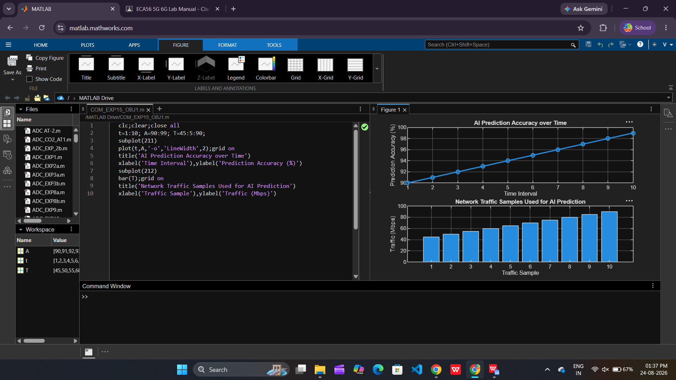

Objective 2: To calculate the Mean Squared Error (MSE) between the predicted and actual network
traffic values to assess prediction performance.

Matlab Code:

clc;clear;close all
t=1:10;
A=[50 55 60 62 68 70 75 80 85 90];
P=[49 54 61 63 67 71 74 81 84 89];
E=(A-P).^2; MSE=mean(E);
disp(['Mean Squared Error (MSE) = ',num2str(MSE)])
subplot(211)
plot(t,E,'-o','LineWidth',2);grid on
title('Squared Error of AI Traffic Prediction'),xlabel('Time Interval'),ylabel('Squared Error')
subplot(212)
bar(MSE);grid on
title('Mean Squared Error (MSE)'),xlabel('AI Prediction Model'),ylabel('MSE')

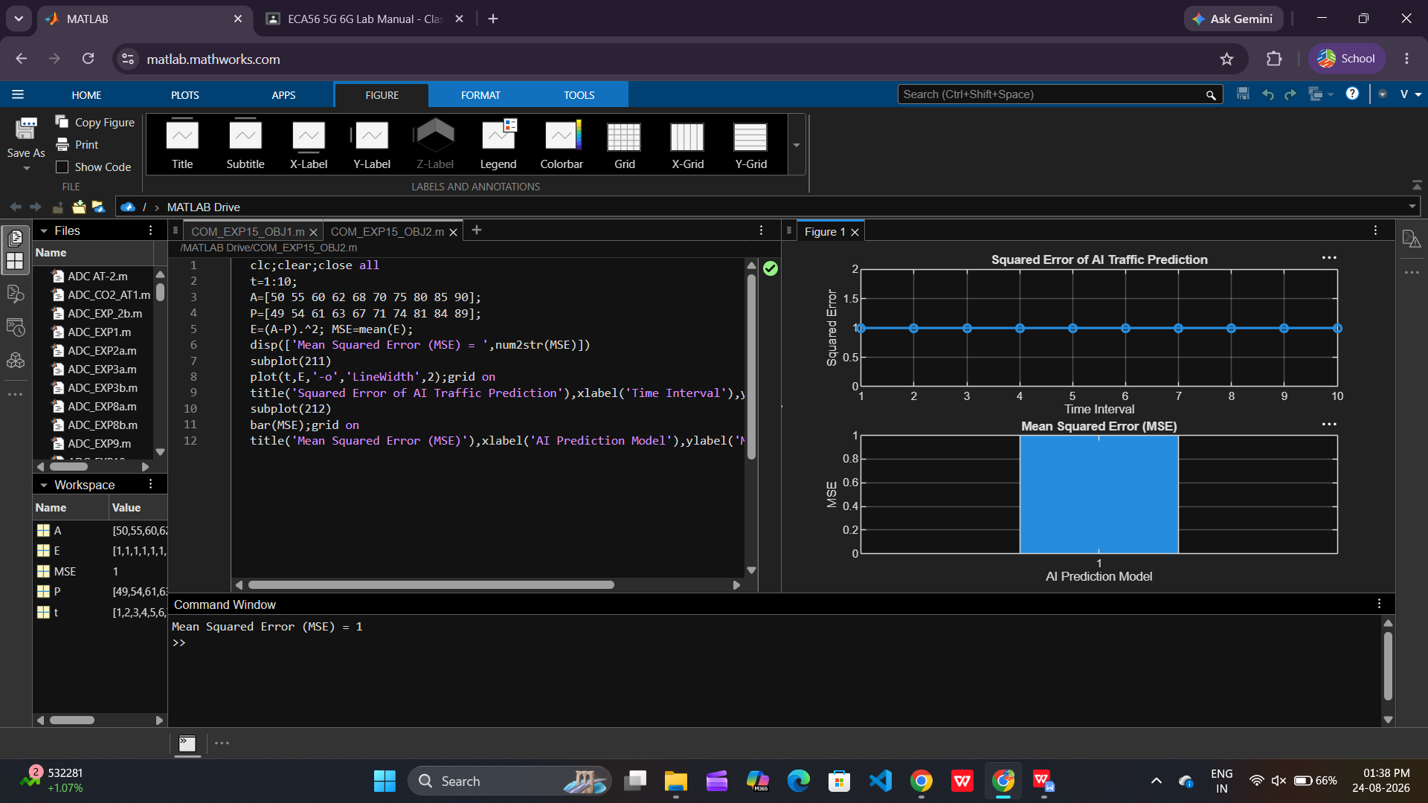

Objective 3: To analyze the impact of AI-based traffic prediction on Network Throughput (Mbps)
and evaluate the improvement in network resource utilization.

Matlab Code:

clc;clear;close all
t=1:10; T=[120 135 150 165 180 195 210 225 240 255];
U=[60 65 70 74 78 82 86 90 94 98];
subplot(211)
plot(t,T,'-o','LineWidth',2);grid on
title('AI-Based Network Throughput'),xlabel('Time Interval'),ylabel('Throughput (Mbps)')
subplot(212)
plot(T,U,'-s','LineWidth',2);grid on
title('Throughput vs Network Utilization'),xlabel('Network Throughput (Mbps)'),ylabel('Network Utilization (%)')
disp('Time Throughput(Mbps) Utilization(%)'),disp([t' T' U'])

